Task 2:

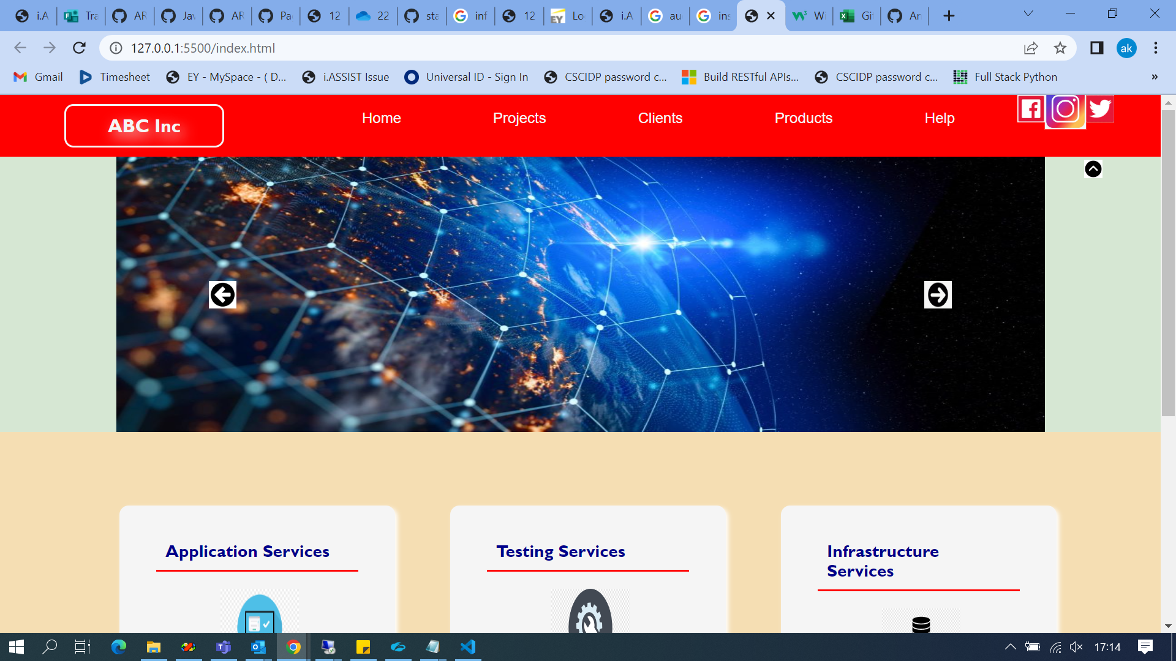

Task 3:

Hovered to right.

Task 4

